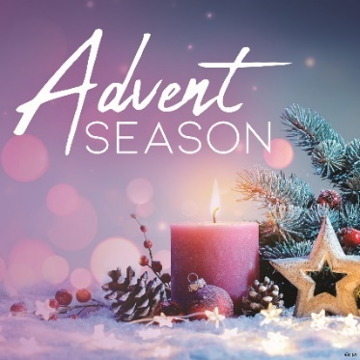
Advent Activities 2025

Nativity Festival
Saturday, December 6th
2:00 – 5:00pm at Holy Family

Monday, December 8th
Solemnity of the Immaculate Conception of the Blessed Virgin Mary
Holy Day of Obligation
6:00pm at Holy Family

Sacrament of Penance

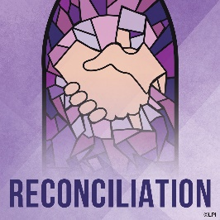
Advent Communal Reconciliation Service with individual reconciliation
- Wednesday, December 3rd, 6:30pm at St. John Baptist de la Salle
- Wednesday, December 10th, 6:00pm at Christ the King
All are welcome!
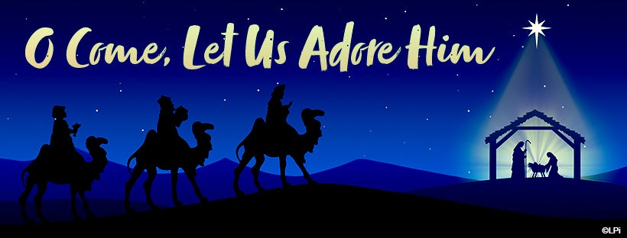

Christmas Programs

- December 13th, St. John Baptist de la Salle, 6:00pm
- December 14th, Christ the King, 12:00pm

Christmas Season Schedule

December 24th, Christmas Eve Mass: 4:00pm, Christ the King
6:00pm, Holy Family

December 25th, Christmas Day Mass:
8:30am, St. John Baptist de la Salle

December 27th, Feast of the Holy Family
5:00pm, St. John Baptist de la Salle

December 28th, Feast of the Holy Family
8:30am, Holy Family 10:30am, Christ the King

December 31st - Mary the Holy Mother of God
5:00pm, Holy Family

January 1, Mary the Holy Mother
9:00am, St. John Baptist de la Salle

January 6th - The Epiphany of the Lord
8:30am, Holy Family
10:30am, Christ the King

January 10th - The Baptism of our Lord
5:00pm, St. John Baptist de la Salle

January 11th - The Baptism of our Lord
8:30am, Holy Family
10:30am, Christ the King

